KIDD’S ZONE
A Step Forward To Your Child’s Bright Future
(A Co- educational English Medium School)
GAUSH NAGAR MANI TOLA DORANDA RANCHI -834002
Time :- 2 hr Subject:- GK
NAME :- _____________________________________
MARKS OBTAINED :- ___________________________
DATE :-______________________________________
Full marks :- 70+10 Pass:-27
Class :-Nursery
1st TERM EXAMINATION 2025-26
Q 1 .Fill in the missing letter (10)
P ______ t ______ t
O ______ i ______ n
T ______ m ______ t ______
C ______ r r ______ t
B ______ i ______ j ______ i
Q 2. Circle the flowers name (10)
Lotus Papaya Kiwi Mango Rose Guava
Lily Grapes Apple Orange Sunflowers Banana
Jasmine Grapes Palm
Q 3. Match the following word (10)
Honey Bee Spider
Bug Butter Fly
Spider Bug
Ant Honey Bee
Butter Fly Ant


Q 4. Match the following Picture (10)

Apple

Banana

Grapes
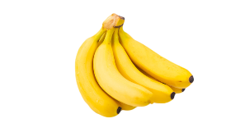
Papaya
Orange

Q 5. Choose The Answer From The Box (10)


Eye Nose Lip Finger Teeth




Q 6. Fill in the Blanks (10)
C ______ w G ______ a ______
D ______ g O ______
C ______ t
Q 7. Match the Following Words (10)
Duck Eagle
Parrot Pigeon
Eagle Duck
Pigeon Crow
Crow Parrot

